**Statistics 251: Lab 1 Handout**

First Name: __Musa________ Last Name: ____Rasheed_________

Student Number: _______25618232___

Students should write the name they are registered with. Do not put nicknames/short forms on the handout. Please write down your answers neatly and do show your work.

Part 1

Write down the R code that you used:

**data = seq(1, 57, by=4)**

**matrix(data, nrow = 3, ncol = 5)**

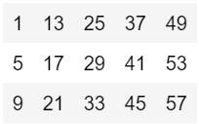

Part 2

1. How many variables are there in the dataset? _____5_____
   1. Quake, Richter, Distance, Soil ,Accel
2. Write down the R code that you used to calculate the mean and variance:

Mean: mean(Earthquake[3])

Variance:

n = length(Earthquake[3])

avg = mean(Earthquake[3])

xi = Earthquake[3]

print((1/(n-1))*sum((xi-avg)^2))

Write down the mean: 45.60. Write down the result from using *var(x)*: 3865.117.

1. Write down the R code that you used to generate the histogram.

data = Earthquake[5]

hist(data)

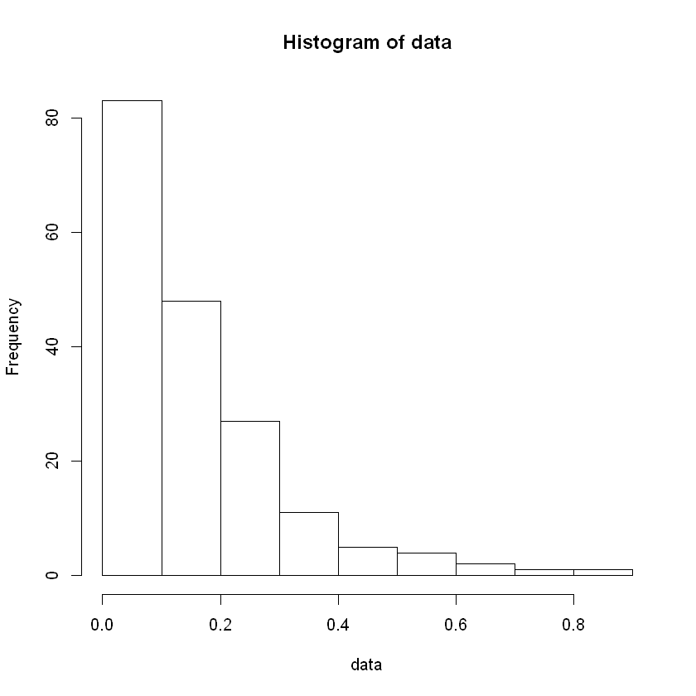

Describe the shape of the histogram.

It is a right skewed distribution whose mean is bigger than its median. The distribution is not very flat, and it is also unimodal.

Five-number summary: min = 0.003, Q1 = 0.04425, median = 0.113, Q3 = 0.21925, max=0.81

Summary(data)

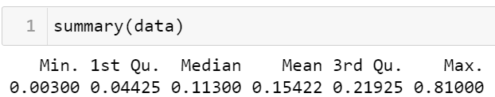

1. Write down the R code that you used to generate the side-by-side boxplots.

options(repr.plot.width=5, repr.plot.height=5)

soil0 = Earthquake[Earthquake[4]==0,2] #Soil type is col 4

soil1 = Earthquake[Earthquake[4]==1,2] #Richter is col 2

par(mfrow = c(1,2))#Makes space for 2 plots (2 row 1 col)

boxplot(soil0, main = "Soil Type 0", ylab = "Richter Scale")

boxplot(soil1, main = "Soil Type 1", ylab = "Richter Scale")

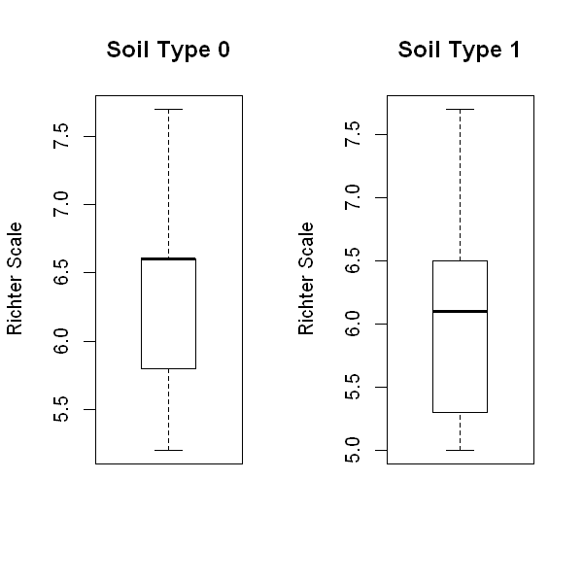

Does the *Richter* intensity differ by *soil* type? Why?

Yes (although this result could be affected by the fact that there was a LOT more data for soil type 1 than type 0.) It appears generally, soil type 0 has more intense earthquakes than soil type 1. Not only is the median shifted upwards for type 0, but so is quartile 1, meaning even lower intensity earthquakes are more powerful. This leads to the conclusion that type 0 soil has more intense earthquakes than type 1.

1. Which type of plot did you use? Scatter Plot

Write down the R code that you used to generate the plot.

d = Earthquake[3]

a = Earthquake[5]

plot(d,a,main = "Acceleration vs Distance", xlab = "Distance (km)", ylab = "Acceleration (m/s^2)")

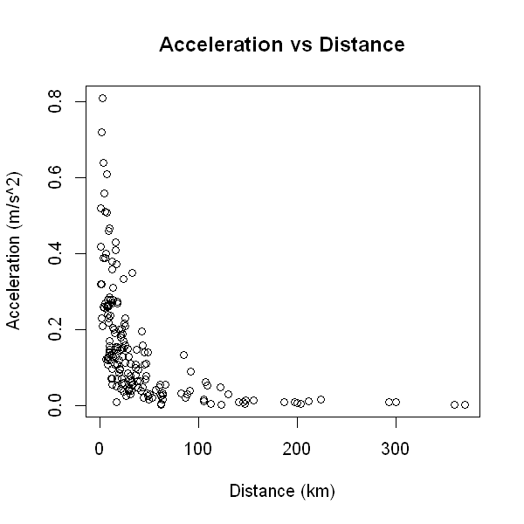

Describe the relationship.

It seems to be some sort of decay plot. As the distance increases, the acceleration decreases.

$$a = e^{-kd}$$

Where k is some constant.